**Introduction**

For the second task (Task 2), I have been asked to prepare assets, content, demonstrating awareness of purpose, listing sources of assets, develop a website with eight interlinked pages, test for functionality, test for purpose, repairing any faults, documenting changes, how the website is suitable for the intended audience, how the website is suitable for the purpose, interactive features, demonstrating awareness of user requirements, taking account of usability, test interactivity, gathered feedback from others, make improvements, review that it meets the needs of purpose, review that it meets the needs of user requirements, considering feedback from others, constraints, refinements, improve accessibility, improve performance, taking account of user feedback, taking account of test results, evaluation of the final design against the design, justification of any changes and finally making recommendations for further improvement.

**A description of the requirements from the brief**

Based on the assignment brief the website requires eight interlinked pages and I have been asked to develop and document a design for it. This design documentation should include:

A description of the user requirements, storyboard, description of styles, templates, formats and interactive features, site map and file structure, description of the assets, fully referenced table of sources, test plan and data, description of styles applied, alternative solutions, design justification.

**An explanation of the target audience**

Based on my research, businesses such as telecommunication, mobile phone and accessories companies. Their average customers demographics include people aged **18** to **45**. They are either single, married with no kids, or married with young children or teens. Their target audience are strongly female, with around **60%** female to **40%** males’ customers. Therefore, this website is to be aimed at users or tech enthusiasts including mainly younger to middle aged consumers, and the website is likely to be more popular among **females** than **males**.

**The intended purpose of the website**

The intended purpose of this website is to serve as a platform that provides a range of services and products from browsing and buying devices and plans to requesting for services and accessing support and contact to users/customers. Each user will be entitled to each of these features across all pages of the site.

**The user requirements for the website**

The user requirements for the website would be a home page to navigate users to certain pages, hyperlinks to different categories of products, a page dedicated for contact options/support, a list of accessibility features to help users with disabilities and challenges, hotspot, search bars and more. The name I have chosen for this website is ‘**MobileNexHub.com**’

The website will have to contain the following pages:

**Homepage**, **Accessories**, **Repairs**, **Sim-Only**, **Deals**, **Products**, **Mobiles**, **Contact Us**.

**A storyboard (with at least eight panels – one per web page) that outline the layout and content (e.g. text, assets and features)**

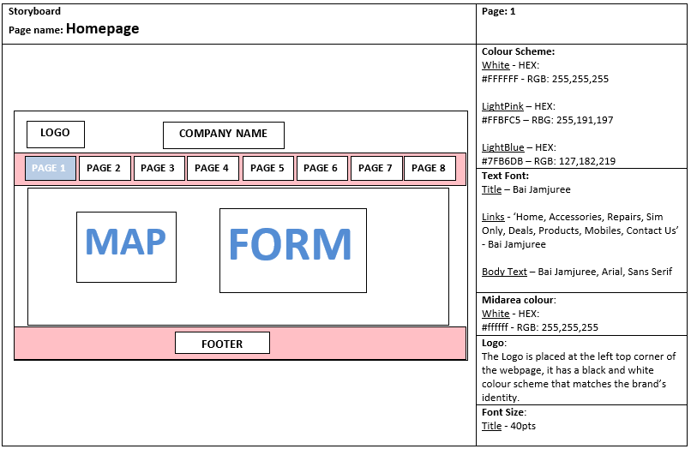

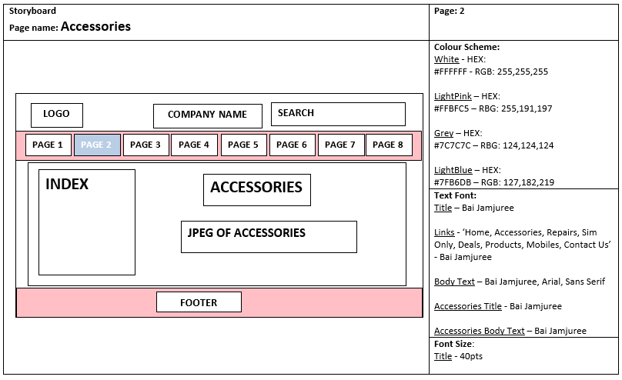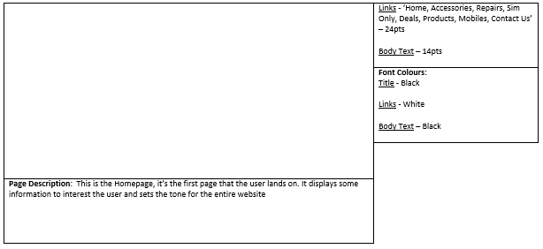

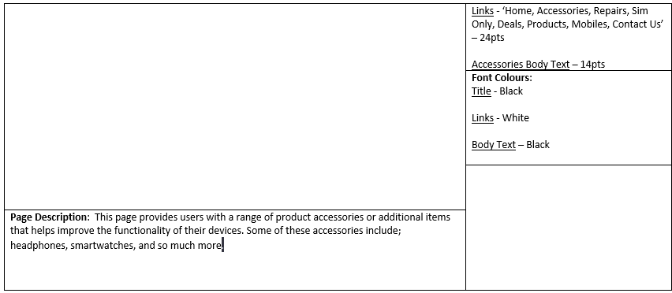

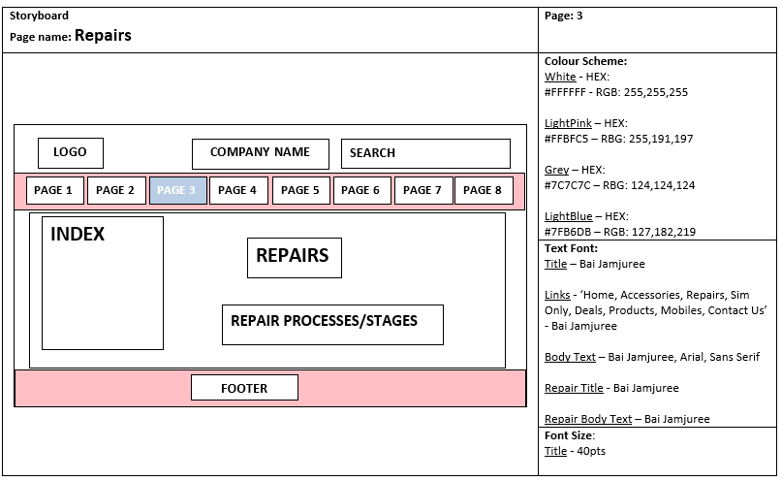

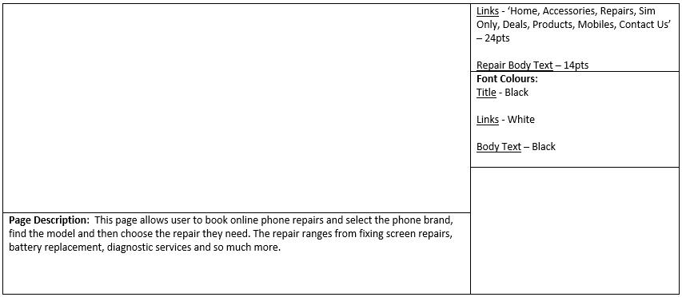

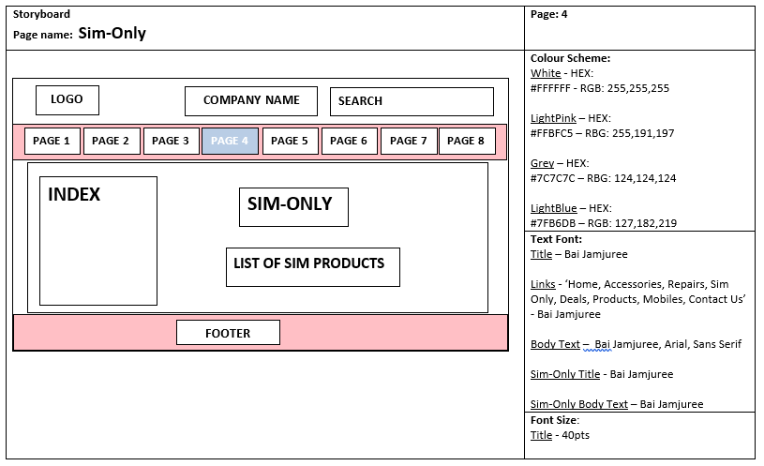

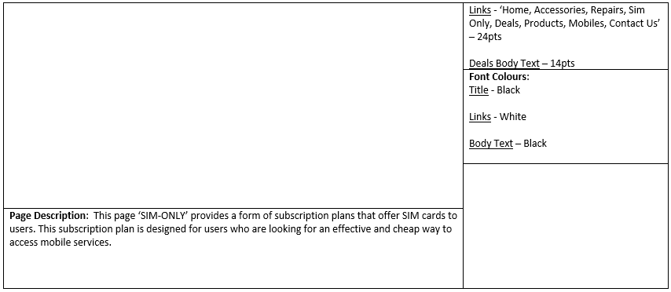

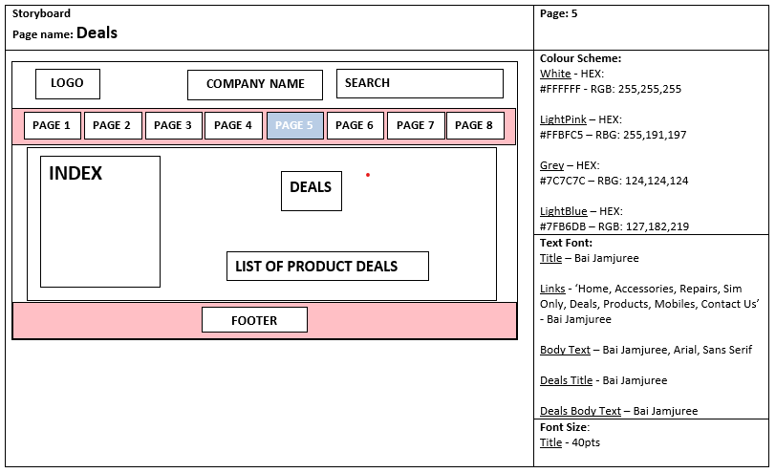

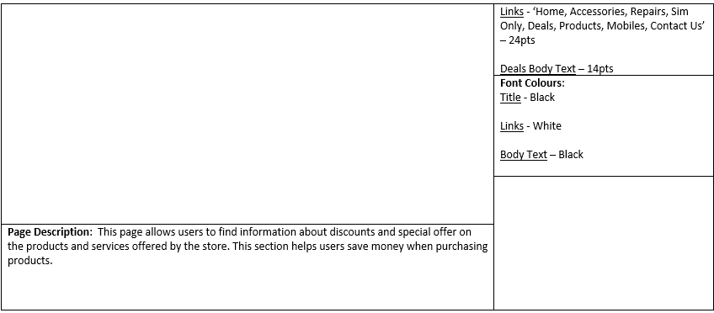

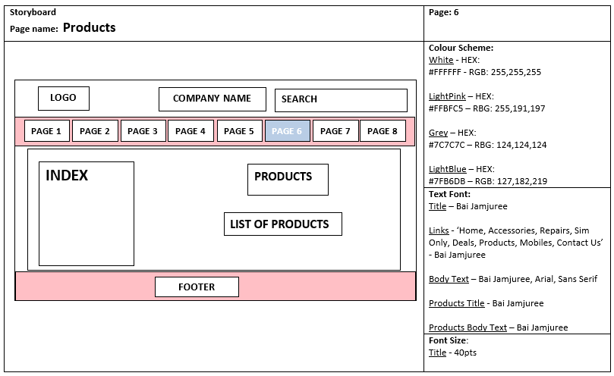

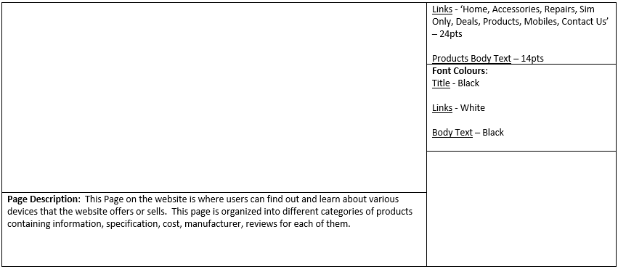

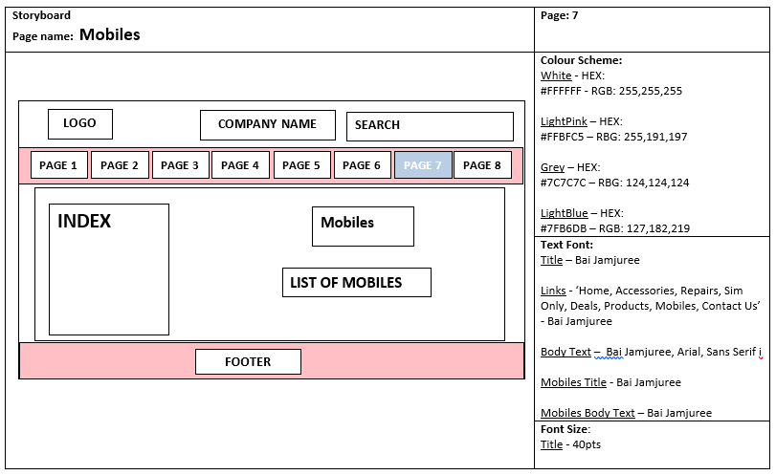

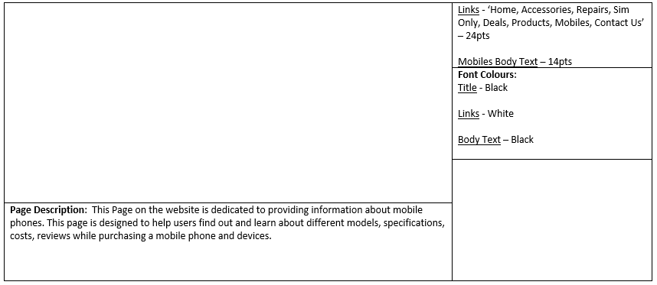

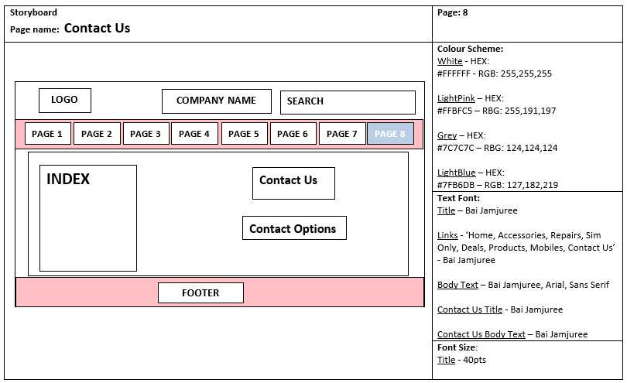

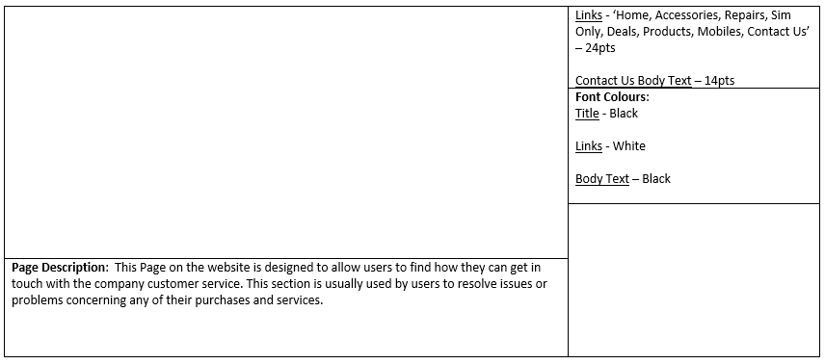

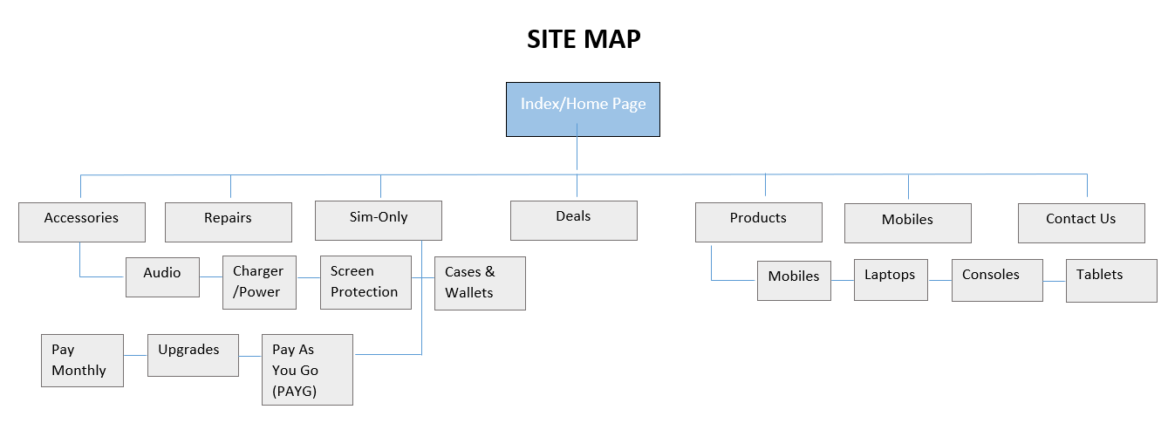 **A site map including a home page and file structure**

***File structure:***

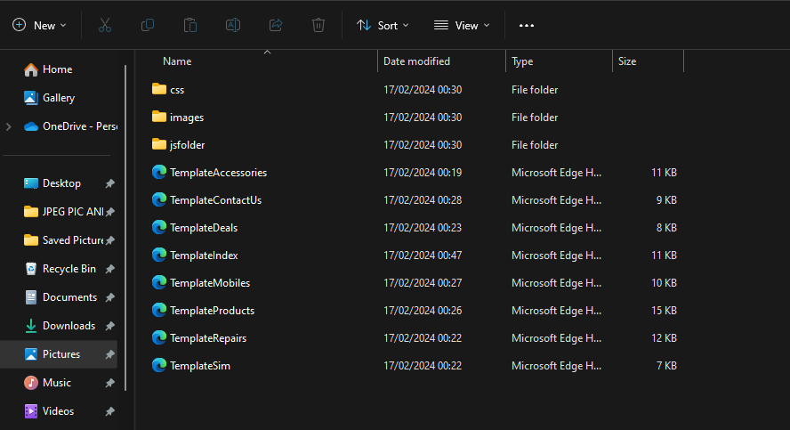

**A list of assets for any original and/or ready-made assets**

***Assets:***

|  |  |  |  |  |
| --- | --- | --- | --- | --- |
| Name of website: MobileWorldStation Website | | | | |
| Learner name: Oluwatobi Salawu | | | | |
| No. | Page | Description | Type  (graphic, audio, etc.) | Source |
| 1 | Homepage | This image is in a slideshow, it directs a user to the sub-section of ‘mobile’ page in the navigation bar on the website. | Samsung Galaxy S24 Ultra | <https://www.tescomobile.com/shop/samsung> |
| 2. | Homepage/Deals | This image is in the homepage, it directs a user to the ‘products’ page on the website. |  | [file:///C:/Users/OLUWATOBILOBA%20SALAWU/Documents/PART%203%20FILES%20TS/images/accessories-deal.png](C://Users/OLUWATOBILOBA%20SALAWU/Documents/PART%203%20FILES%20TS/images/accessories-deal.png) |
| 3 | Homepage/Deals | This image is in a section on the homepage, it directs a user to the ‘deals’ page on the website. |  | [file:///C:/Users/OLUWATOBILOBA%20SALAWU/Documents/PART%203%20FILES%20TS/images/deals%20image.jpeg](C://Users/OLUWATOBILOBA%20SALAWU/Documents/PART%203%20FILES%20TS/images/deals%20image.jpeg) |
| 4 | Mobiles | iPhone 15 Pro - This image is part of the list of phones on the ‘mobiles’ page on the website. |  | [file:///C:/Users/OLUWATOBILOBA%20SALAWU/Documents/PART%203%20FILES%20TS/images/iphone15-removebg-preview.png](C://Users/OLUWATOBILOBA%20SALAWU/Documents/PART%203%20FILES%20TS/images/iphone15-removebg-preview.png) |
| 5 | Mobiles | Google Pixel 8- This image is part of the list of phones on the ‘mobiles’ page on the website. |  | [file:///C:/Users/OLUWATOBILOBA%20SALAWU/Documents/PART%203%20FILES%20TS/images/Google%20Pixel%208.png](C://Users/OLUWATOBILOBA%20SALAWU/Documents/PART%203%20FILES%20TS/images/Google%20Pixel%208.png) |
| 6 | Mobiles | Galaxy S24 Ultra 5G - This image is part of the list of phones on the ‘mobiles’ page on the website. |  | [file:///C:/Users/OLUWATOBILOBA%20SALAWU/Documents/PART%203%20FILES%20TS/images/samsung-galaxy-s21.png](C://Users/OLUWATOBILOBA%20SALAWU/Documents/PART%203%20FILES%20TS/images/samsung-galaxy-s21.png) |
| 7 | Mobiles | Sony Xperia 1 V- This image is part of the list of phones on the ‘mobiles’ page on the website. |  | [file:///C:/Users/OLUWATOBILOBA%20SALAWU/Documents/PART%203%20FILES%20TS/images/sony-xperia-phone.png](C://Users/OLUWATOBILOBA%20SALAWU/Documents/PART%203%20FILES%20TS/images/sony-xperia-phone.png) |
| 8 | Mobiles | Motorola Razr 40 5G Sage Green - This image is part of the list of phones on the ‘mobiles’ page on the website. |  | [file:///C:/Users/OLUWATOBILOBA%20SALAWU/Documents/PART%203%20FILES%20TS/images/motorola-phone.png](C://Users/OLUWATOBILOBA%20SALAWU/Documents/PART%203%20FILES%20TS/images/motorola-phone.png) |
| 9 | Mobiles | TCL 40R 5G - This image is part of the list of phones on the ‘mobiles’ page on the website. |  | [file:///C:/Users/OLUWATOBILOBA%20SALAWU/Documents/PART%203%20FILES%20TS/images/TCL-phone.png](C://Users/OLUWATOBILOBA%20SALAWU/Documents/PART%203%20FILES%20TS/images/TCL-phone.png) |
| 10 | Accessories | Jabra Evolve2 85 USB-C MS Stereo Headset - This headphone image is part of the list of accessories under the Audio on the ‘Accessories’ page on the website. |  | [file:///C:/Users/OLUWATOBILOBA%20SALAWU/Documents/PART%203%20FILES%20TS/images/headphone-2.jpg](C://Users/OLUWATOBILOBA%20SALAWU/Documents/PART%203%20FILES%20TS/images/headphone-2.jpg) |
| 11 | Accessories | Poly Voyager Free 60+ - This air pod image is part of the list of accessories under the Audio on the ‘Accessories’ page on the website. |  | [file:///C:/Users/OLUWATOBILOBA%20SALAWU/Documents/PART%203%20FILES%20TS/images/airpods1.jpg](C://Users/OLUWATOBILOBA%20SALAWU/Documents/PART%203%20FILES%20TS/images/airpods1.jpg) |
| 12 | Accessories | Cygnet Essential Wireless Charger 10W- This wireless charger image is part of the list of accessories under the charger(power) on the ‘Accessories’ page. |  | [file:///C:/Users/OLUWATOBILOBA%20SALAWU/Documents/PART%203%20FILES%20TS/images/wireless-charger.jpg](C://Users/OLUWATOBILOBA%20SALAWU/Documents/PART%203%20FILES%20TS/images/wireless-charger.jpg) |
| 13 | Accessories | iPhone 20W charger- This charger image is part of the list of accessories under the charger(power) on the ‘Accessories’ page. |  | [file:///C:/Users/OLUWATOBILOBA%20SALAWU/Documents/PART%203%20FILES%20TS/images/charger.png](C://Users/OLUWATOBILOBA%20SALAWU/Documents/PART%203%20FILES%20TS/images/charger.png) |
| 14 | Accessories | iPhone Screen Protection- This Screen Protector image is part of the list of accessories under the screen protection section on the ‘Accessories’ page. |  | [file:///C:/Users/OLUWATOBILOBA%20SALAWU/Documents/PART%203%20FILES%20TS/images/screen%20protection.png](C://Users/OLUWATOBILOBA%20SALAWU/Documents/PART%203%20FILES%20TS/images/screen%20protection.png) |
| 15 | Accessories | Fair phone 4 Screen Protector v1 Blue Light- This Screen Protector image is part of the list of accessories under the screen protection section on the ‘Accessories’ page. |  | [file:///C:/Users/OLUWATOBILOBA%20SALAWU/Documents/PART%203%20FILES%20TS/images/screenprotector2.png](C://Users/OLUWATOBILOBA%20SALAWU/Documents/PART%203%20FILES%20TS/images/screenprotector2.png) |
| 16 | Accessories | iPhone 14 Cases- This iPhone 14 Case image is part of the list of accessories under the Cases & Wallets section on the ‘Accessories’ page. |  | [file:///C:/Users/OLUWATOBILOBA%20SALAWU/Documents/PART%203%20FILES%20TS/images/Cases.png](C://Users/OLUWATOBILOBA%20SALAWU/Documents/PART%203%20FILES%20TS/images/Cases.png) |
| 17 | Accessories | OtterBox Commuter Series for Samsung Galaxy A40- This Samsung phone Case image is part of the list of accessories under the Cases & Wallets section on the ‘Accessories’ page. |  | <file:///C:/Users/OLUWATOBILOBA%20SALAWU/Documents/PART%203%20FILES%20TS/images/samsungcase.jpg> |
| 18 | Products | Apple iPad Air 10.9 - This Tablet is part of the list of Products on the ‘Products’ page under the tablets section. |  | [file:///C:/Users/OLUWATOBILOBA%20SALAWU/Documents/PART%203%20FILES%20TS/images/apple-tablet.jpg](C://Users/OLUWATOBILOBA%20SALAWU/Documents/PART%203%20FILES%20TS/images/apple-tablet.jpg) |
| 19 | Products | Samsung Galaxy Tab S8 Plus(5G) - This Tablet is part of the list of Products on the ‘Products’ page under the tablets section. |  | [file:///C:/Users/OLUWATOBILOBA%20SALAWU/Documents/PART%203%20FILES%20TS/images/saamsung-galaxy-tablet.jpg](C://Users/OLUWATOBILOBA%20SALAWU/Documents/PART%203%20FILES%20TS/images/saamsung-galaxy-tablet.jpg) |
| 20 | Products | Apple 12.9-inch iPad Pro- This Tablet is part of the list of Products on the ‘Products’ page under the tablets section. |  | [file:///C:/Users/OLUWATOBILOBA%20SALAWU/Documents/PART%203%20FILES%20TS/images/apple-tablet2.jpg](C://Users/OLUWATOBILOBA%20SALAWU/Documents/PART%203%20FILES%20TS/images/apple-tablet2.jpg) |
| 21 | Products | Samsung Galaxy Chromebook Go 14" 4G- This Laptop is part of the list of Products on the ‘Products’ page under the laptop section. |  | [file:///C:/Users/OLUWATOBILOBA%20SALAWU/Documents/PART%203%20FILES%20TS/images/Dell-Laptop.webp](C://Users/OLUWATOBILOBA%20SALAWU/Documents/PART%203%20FILES%20TS/images/Dell-Laptop.webp) |
| 22 | Products | Microsoft Surface Pro 9 5G- This Laptop is part of the list of Products on the ‘Products’ page under the laptop section. |  | [file:///C:/Users/OLUWATOBILOBA%20SALAWU/Documents/PART%203%20FILES%20TS/images/Windows-surface-pro-laptop.webp](C://Users/OLUWATOBILOBA%20SALAWU/Documents/PART%203%20FILES%20TS/images/Windows-surface-pro-laptop.webp) |
| 23 | Sim-Only | This image just shows that the plan costs £10 for 20GB worth of data |  | [file:///C:/Users/OLUWATOBILOBA%20SALAWU/Documents/PART%203%20FILES%20TS/images/%C2%A310-20GB.jpg](C://Users/OLUWATOBILOBA%20SALAWU/Documents/PART%203%20FILES%20TS/images/%C2%A310-20GB.jpg) |
| 24 | Sim-Only | This image just shows that the plan costs £15 for 20GB worth of data |  | [file:///C:/Users/OLUWATOBILOBA%20SALAWU/Documents/PART%203%20FILES%20TS/images/20GB-15.jpg](C://Users/OLUWATOBILOBA%20SALAWU/Documents/PART%203%20FILES%20TS/images/20GB-15.jpg) |
| 25 | Sim-Only | This image just shows that the plan costs £25 for Unlimited data |  | <file:///C:/Users/OLUWATOBILOBA%20SALAWU/Documents/PART%203%20FILES%20TS/images/%C2%A325-unlimited.jpg> |
| 26 | Deals | MacBook Bundles - This is also image describes the deal offered f0r MacBook pros |  | [file:///C:/Users/OLUWATOBILOBA%20SALAWU/Documents/PART%203%20FILES%20TS/images/Macbook-deals.webp](C://Users/OLUWATOBILOBA%20SALAWU/Documents/PART%203%20FILES%20TS/images/Macbook-deals.webp) |
| 27 | Deals | Samsung Bundles - This is also image describes the deal offered for Samsung galaxy S21s |  | [file:///C:/Users/OLUWATOBILOBA%20SALAWU/Documents/PART%203%20FILES%20TS/images/samsungbundle.png](C://Users/OLUWATOBILOBA%20SALAWU/Documents/PART%203%20FILES%20TS/images/samsungbundle.png) |
| 28 | Deals | iPhone Bundles - This is also image describes the deal offered for iPhone 14 Bundle |  | [file:///C:/Users/OLUWATOBILOBA%20SALAWU/Documents/PART%203%20FILES%20TS/images/iphonedeal.png](C://Users/OLUWATOBILOBA%20SALAWU/Documents/PART%203%20FILES%20TS/images/iphonedeal.png) |
| 29 | Homepage | This is image is displayed on the homepage as a link to the products page |  | [file:///C:/Users/OLUWATOBILOBA%20SALAWU/Documents/PART%203%20FILES%20TS/images/laptop-removebg.png](C://Users/OLUWATOBILOBA%20SALAWU/Documents/PART%203%20FILES%20TS/images/laptop-removebg.png) |
| 30 | Homepage | The headphone image is displayed on the homepage to act as a link to the accessories page |  | [file:///C:/Users/OLUWATOBILOBA%20SALAWU/Documents/PART%203%20FILES%20TS/images/headphone-removebg.png](C://Users/OLUWATOBILOBA%20SALAWU/Documents/PART%203%20FILES%20TS/images/headphone-removebg.png) |
| 31 | Products | This image shows a game console that is sold on the product page |  | <file:///C:/Users/OLUWATOBILOBA%20SALAWU/Documents/PART%203%20FILES%20TS/images/xbox-console.png> |
| 32 | Products | This shows that a PS5 is also being sold on the products page under the console section. |  | [file:///C:/Users/OLUWATOBILOBA%20SALAWU/Documents/PART%203%20FILES%20TS/images/tablet-removebg-preview.png](C://Users/OLUWATOBILOBA%20SALAWU/Documents/PART%203%20FILES%20TS/images/tablet-removebg-preview.png) |

**A test plan and data, giving an outline of the range of tests that will be used to check the functionality of the website.**

***Test Plan:***

|  |  |  |  |  |  |
| --- | --- | --- | --- | --- | --- |
| Name of web page: | | MobileWorldStation Website | | | |
| Date of testing: | | 10/02/2024 | | | |
| Name of tester: | | Oluwatobi Salawu | | | |
| No. | Test description | | Expected outcome | Actual outcome | Comments |
| 1 | **Menu** & **Dropdown** **Links** – I should be able to hover over each page linked and when clicked should direct me to the selected page. | | The menu should drop down and display the right links and when clicked should direct the user to the selected page. | The outcome was different when I hovered over the main links on the menu the sub section did not show. This may be as a result of the browser or internet connection. Cause this section is well programmed the code was correct and intact. | A section of CSS and JavaScript code was used.  It also the hovering process and when the users hover over the links on the menu it changes the mouse cursor to a pointer. |
| 2 | **Buttons/Call to Actions** (**CTAs**) – All buttons on each page of the website should direct the me(user) correctly to their destination | | When the buttons are clicked the user should be directed to the page, they selected | The buttons worked perfectly as expected, I was directed to another page after the buttons was clicked. | A section of HTML, CSS and JavaScript was used.  Button |
| 3 | **Search Box** – The search button is a navigation tool, When I clicked the search bar and type in a keyword, results about such will be displayed. | | When the search bar is clicked on the user is to input a keyword or product they are searching for, while typing in this keyword some suggested result should appear. Then when this keyword is entered the same set or similar results will be displayed. | It doesn’t work so perfectly, it seems like once the user is typing in the keyword, the suggested results do not pop up. | A section of HTML, CSS and JavaScript was used.  Input type - Search |
| 4 | **Image Loading (Buffering)** – I will load the images on each page of the website and check that the images display correctly. | | When a user is on a page the images should automatically load and display. The image also has ALT text in case the image doesn’t display | The images displayed correctly with no issues. But when my internet connection went down the image didn’t display but the ALT text acted as a backup. | A section of HTML, CSS and JavaScript was used.  Image data. |
| 5 | **Page loading** – I will visit every page on the website. To determine how long /time taken for the page to load and display. | | The estimated time I calculated for the page to load should be (**0.49 seconds**). Any other time taken below this estimated time will either be as a result of the user internet connection or device. | The pages on the website took less than the estimated time to load. The time it took was (**0.33 seconds**) | This is to analyse the time taken for each page on the website to load. |
| 6 | **Forms** – I will try and fill out the form on some pages of the website such as contact page to determine if it performs the required action. | | When a user decides to fill out the contact form, the text box should allow the user to fill in text/words and it should also allow the correct data type such as (phone number, name, and email) to be entered. After the user has correctly filled out this form a submit/done button should be at the end of the form layout. | The forms allowed me to input the required data as expected, and I was able to use the submit button when I finished. | A section of HTML, CSS and JavaScript was used.  Input Data |
| 7 | **Usability/User Experience –** I will check out every page on the website and try out every feature (hotspots, hyperlinks, navigation tools etc.) | | When a user visits this website, the user should be happy and satisfied with the features, ranging from the layout /design, how the site is structured and described. | The website was easy to use and navigate as expected | With the use of HTML, CSS and JAVASCRIPT. All this was possible as a result of a well-designed and programmed website. |

**A brief description of alternative solutions for the intended website**

***Alternative design***:

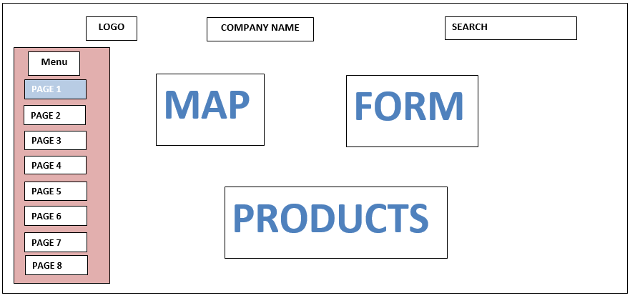

In this alternative design I considered the structure of the design and there’s more that can be improved in the layout, colour scheme to help enhance the user engagement. The navigation menu can also be made easy for users to find things easily.

(This description should include more details as I could seek feedback from users to make more improvement based on their perspective and experience. But the website is still in the development Stage.)

**Justify your design decisions, including why alternative designs were rejected.**

I rejected this alternative design for a few reasons. The alternative design had no footer in its navigation which is needed for essential information. A footer acts a feature that’s user friendly and helps improve the user experience and usability of the website. Another reason was because of the absence of action buttons, without action buttons on the website the user engagement and specific interaction that will help improve the user experience and usability will be reduced or completely eliminated. Adding image description and alt text is also important as it improve the accessibility standards and it allows more users to visit and access information on the website such as people with disability and difficulties.

These design features are created in other to improve user experience, accessibility, usability and to make sure that the website runs efficiently.

**Explain how the website will fulfil the intended purpose and meet the user requirements.**

This website is designed to meet the user requirements and fulfil its intended purpose. Users can easily navigate through each and every of the website such as Accessories, Repairs, Sim-Only, Deals, Products, Mobiles, and Contact Us directly from the index/home page. The dropdown menu contains hyperlinks that allows user to access different categories of products depending on each page/links selected. This website also contains some accessibility features that can help users with disabilities. Hotpots, Search bars and Action buttons provides a user-friendly experience on the website across each page. Overall, this website acts a comprehensive platform for users to be able to find information and learn about various products.

**Consider the constraints, e.g. software availability and whether or not these will have an impact on developing the website.**

Hardware and Software Availability:

This website should be compatible with multiple hardware and software platforms. The website should be developed in a way that it will be accessible across different devices to provide better user experience.

Accessibility:

The website should be accessible to users with disabilities and difficulties. Features such as Alt text, screen reading should be embedded in the website. Without this accessibility features, the website will have limited audience and users with disability and difficulties won’t have access.

Browser Compatibility:

Various browsers interpret code in a special way and a well-developed website will support multiple browser compatibility. If the website is not well developed to support cross-platform compatibility users will have issues or will not be able to access the website with a different browser.

File and File Formats:

The type of media file and formats used can affect the performance of the website. If files that are large or corrupted are used on the website this will slow down the performance and bring about bad user experience.

Client-Side Functionality:

Client-side processing scripting language like JavaScript is used on the website to create interactive features and tools to improve the website’s efficiency. Without the use of scripting language, the website won’t be able to be interactive and responsive thereby affecting the user experience and performance.

Performance (Bandwidth, Processor, Memory):

The performance of a website is usually determined by factors like bandwidth, processing speed and memory. A low performance will result in a slow page loading, unresponsiveness (not responsive) and reduced user experience.

Availability of Web Plugins:

The website usually depends on the type of web plugins used. This can also be a drawback has different devices and web browsers may not support this type of tool. Then an alternative design or information will need to be considered for the use of this feature.

**Justification:**

Overall, I believe my design and structure of the website matches the purpose and target audience as expected. The aim of the site is to allow users to find information and purchase a wide range of products/services. The website design I created is flexible and able to contain its content, whilst also having the potential for expansion after the design is constructed. This allows for future improvements to be made once the design has been established. There is much room for improvement in my design, I believe that – with more time and knowledge this can be achieved.